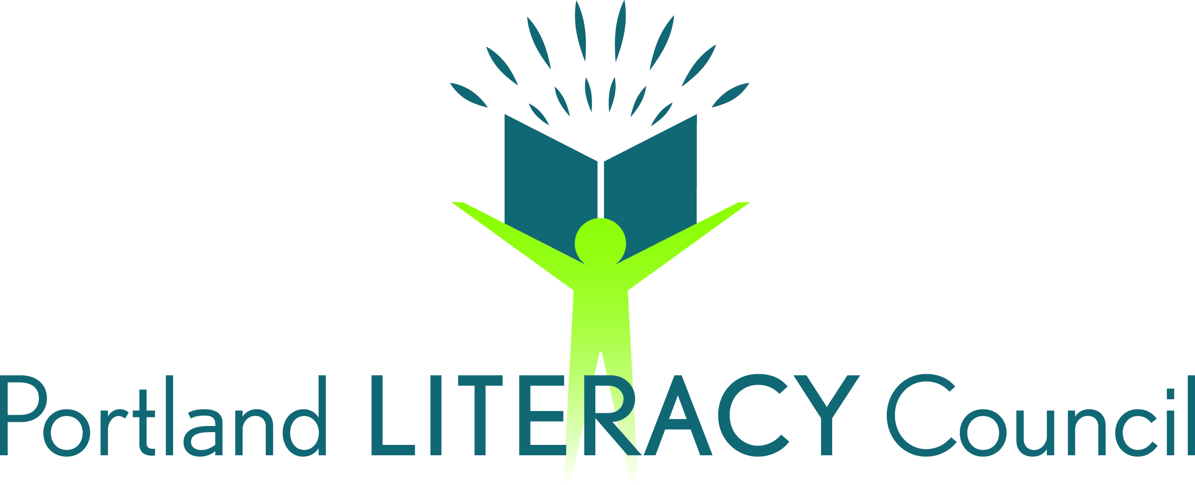

2016 COMMUNITY GRANTS PROGRAM
REQUEST FOR PROPOSALS
Announcement: September 16, 2016
Application Deadline: 5 PM, November 18, 2016

Portland Literacy Council (PLC) invites applications for our Community Grants program.
- These grants are available to Portland metro-area literacy programs that advance Adult Basic Education, GED preparation, or English-as-a-Second Language instruction.
- Grants support existing projects or programs, and may cover operational or program expenses.
- Grants are limited to $500.
- Previous recipients are eligible to apply for the same or another program/project.
- To be eligible, organizations must provide proof of non-profit status.
- Agencies receiving grants must consent to be profiled in LiteracyLinks, PLC’s online newsletter.
- The deadline for applications to be received is 5 PM, November 18, 2016.

To apply: Submit a letter (email or hardcopy) describing, in 500 words or less, the literacy project for which funding is requested. Your letter should cover the following information:
- Name of the program or project and the name of the sponsoring organization
- Name and phone number of the person to contact if we have questions about the grant proposal
- Students served
- Project’s goals
- How a community grant will advance the project mission
Be sure to include a copy of your organization’s IRS 501(c)(3) tax exemption letter or other acceptable evidence of nonprofit status. Applications will not be considered without this documentation.

Contact: Cheryl Thoen, PLC Board of Directors
Email: | grants@portlandliteracy.org | US Mail: | Community Grants Program  Portland Literacy Council  P.O. Box 2872  Portland, OR 92708
Portland Literacy Council (PLC) is a nonprofit organization founded in 1993. PLC is dedicated to promoting literacy programs throughout the Portland metropolitan area. PLC efforts include: delivering volunteer tutor training programs, hosting an annual literacy tutor conference, publishing the LiteracyLinks newsletter, and sponsoring local literacy projects. Our mission is to support literacy programs throughout the Portland metropolitan area. We strive to ensure that a basic education is available to everyone.
Visit the Portland Literacy Council web site, www.portlandliteracy.org, for more information.

