

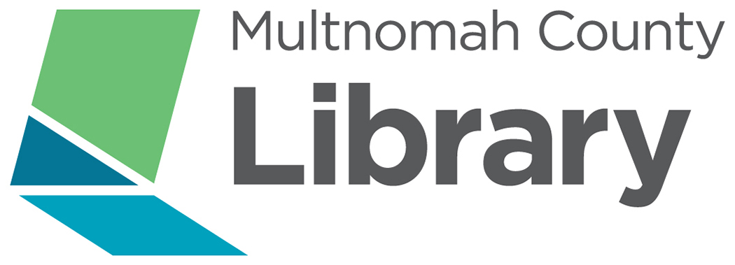

**Midland Library**

**805 SE 122nd Ave**

**Tuesdays 5-7pm**

**Ongoing**

**For more information, call 503.577.9984**

Volunteer tutors needed to help adults prepare for the GED exam, learn how to read, and/or improve English skills. Tutors will work with adults to improve reading, writing, basic math and/or speaking, reading and writing in English. Training provided.

Adult Literacy Tutors!